DIGESTIVE SYSTEM ROLE PLAY:
INSTRUCTIONS

- Draw boxes in the playground with chalk like as shown below

- Label each box with the posters provided below
Mouth
Oesophagus
Stomach
Small intestine
Large intestine
Anus

Blood stream

- The last two pages of this document needed to be printed out as coloured labels and cut up.
- Give each student a sticker
- Food molecules need to link arms to show they haven´t been digested yet! You should have one giant molecule!!
- Enzymes and digestive juices need to organize themselves into the correct box drawn on the ground e.g. salivary amylase will be in the mouth

Small intestine
Lipase, bile, pancreatic amylase
Stomach
Protease and acid
Mouth
Salivary amylase
Anus
Large intestine
Oesophagus

- Put the linked group of food molecules into the ‘mouth’.
- As the students move from box to box the various enzymes should separate them from the main group
- In the small intestine the amino acids, glucose, fatty acids and glycerol should move into the bloodstream
- The water moves out form the large intestine into the bloodstream
- Only fibre should be left in the anus!

MOUTH

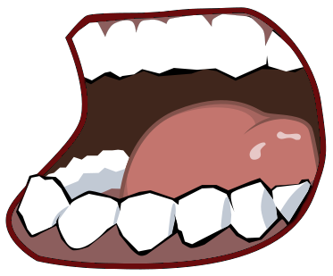
OESOPHAGUS
STOMACH

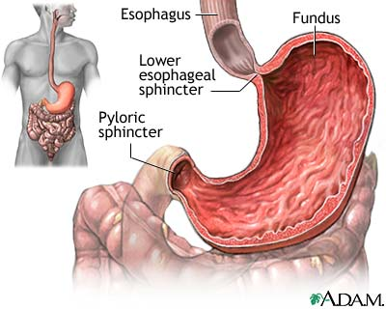
SMALL
INTESTINE
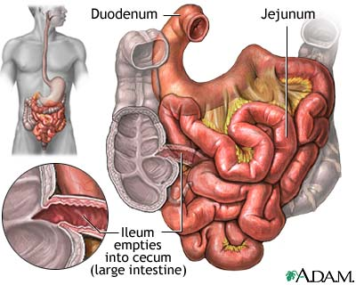
BLOOD
STREAM
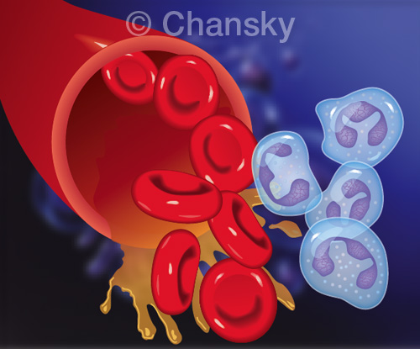

Large Intestine
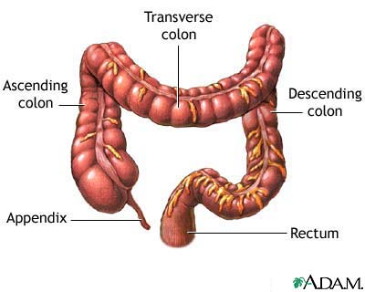
Anus

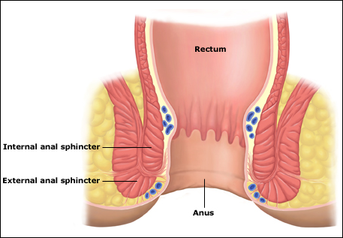

Fibre | Water
Sugar | Sugar
Sugar | Sugar
Amino acid | Amino acid
Amino acid | Amino acid
Glycerol | Fatty acids
Glycerol | Fatty acids
Salivary Amylase | Pancreatic  Amylase
Bile | Protease 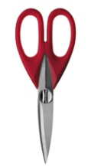
Protease | Lipase
Acid | Acid

